**University of Information Technology**

**Homework 01: Data Design**



**SYSTEMS ANALYSIS AND DESIGN**

**Instructor: Cao Thi Nhan**

**Students: Group 3**

**March 12, 2023**

**Table of Contents**

**Home Work** 2

**1. Tracking product inventories and sales of company products** 2

**A. ERD** 2

**B. Sample Data** 2

**C. Relation Model** 3

**2. Air ticket booking system** 4

**A. ERD** 4

**B. Sample Data** 4

**C. Relation Model** 5

**Task and member assignment table:** 5

# **Home Work**

**1. Tracking product inventories and sales of company products**

**A. ERD**

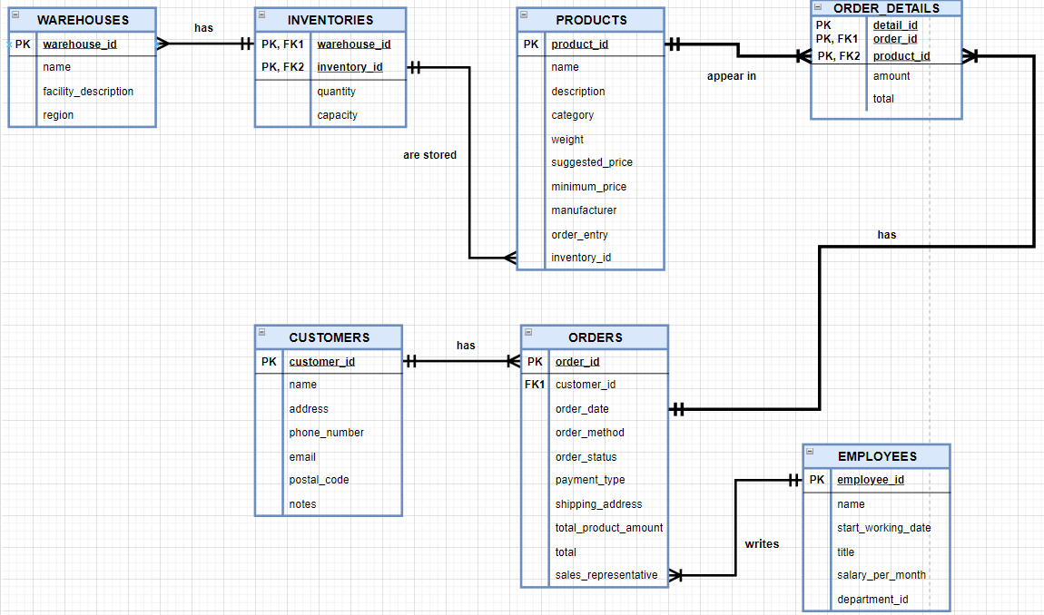

**B. Sample Data**

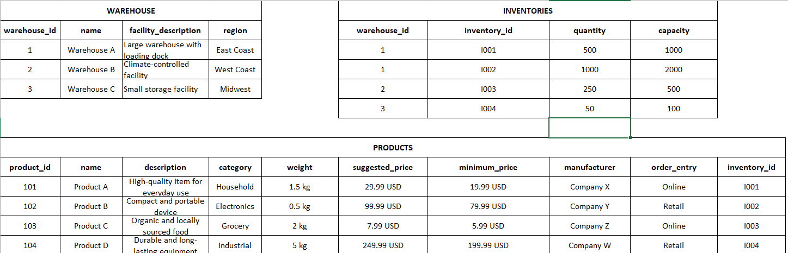

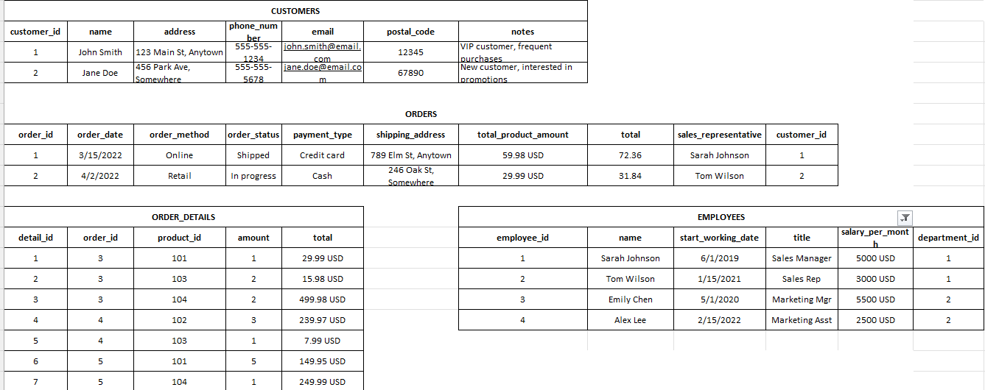

**C. Relation Model**

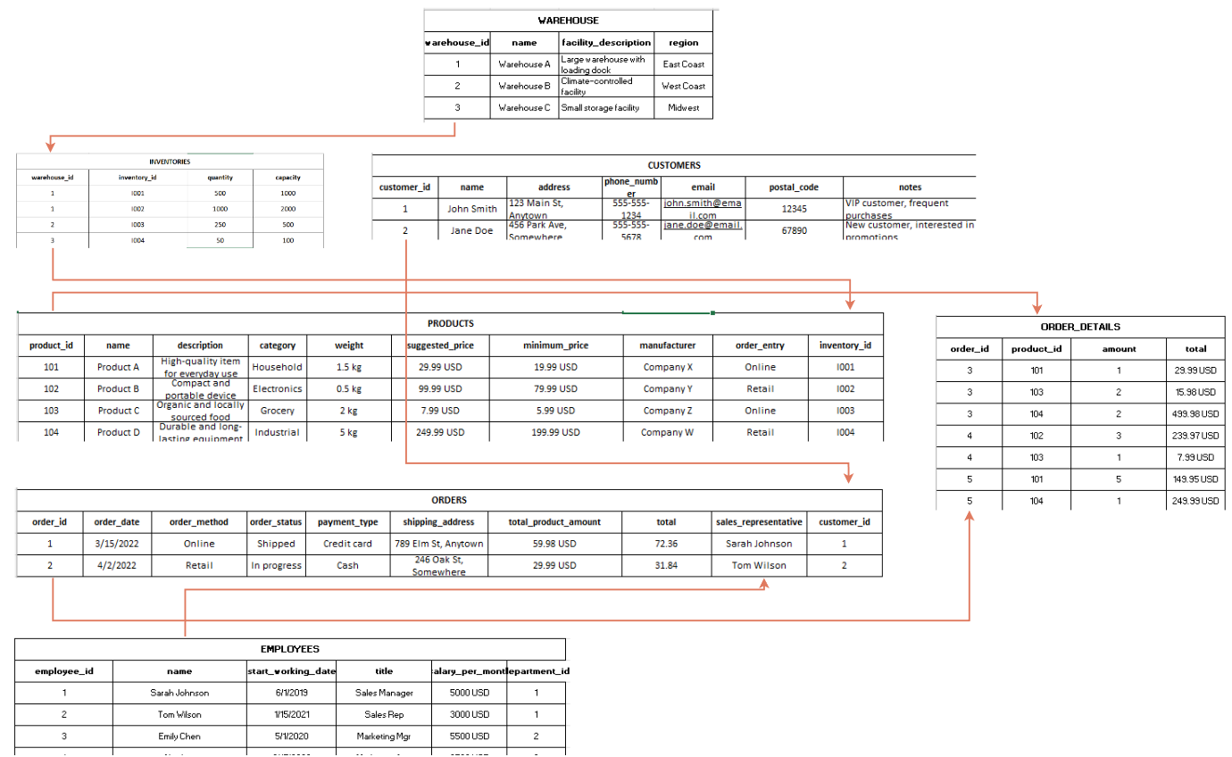

**2. Air ticket booking system**

**A. ERD**

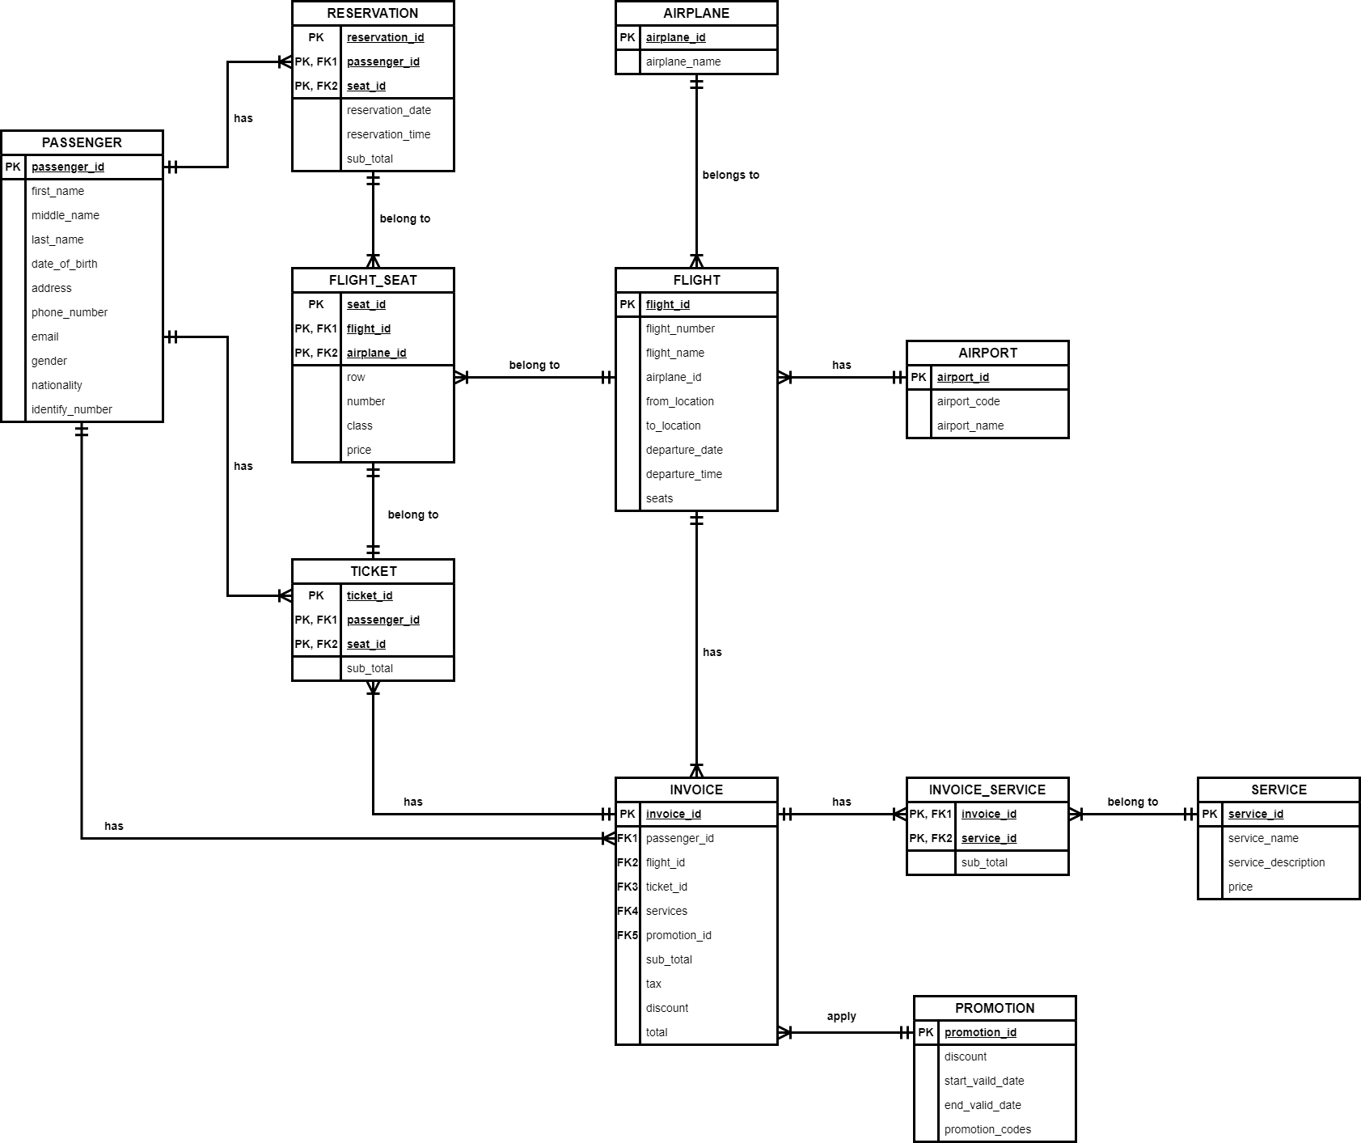

**B. Sample Data**

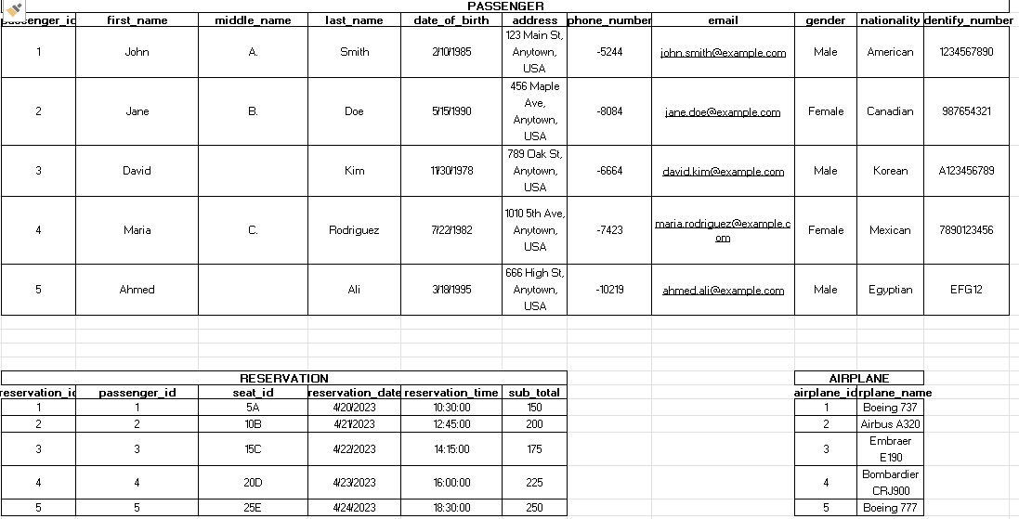

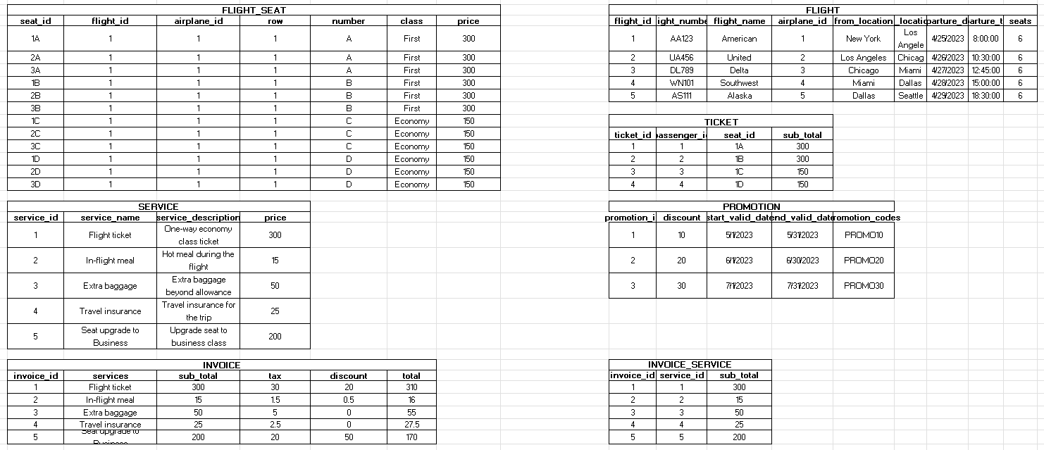

**C. Relation Model**

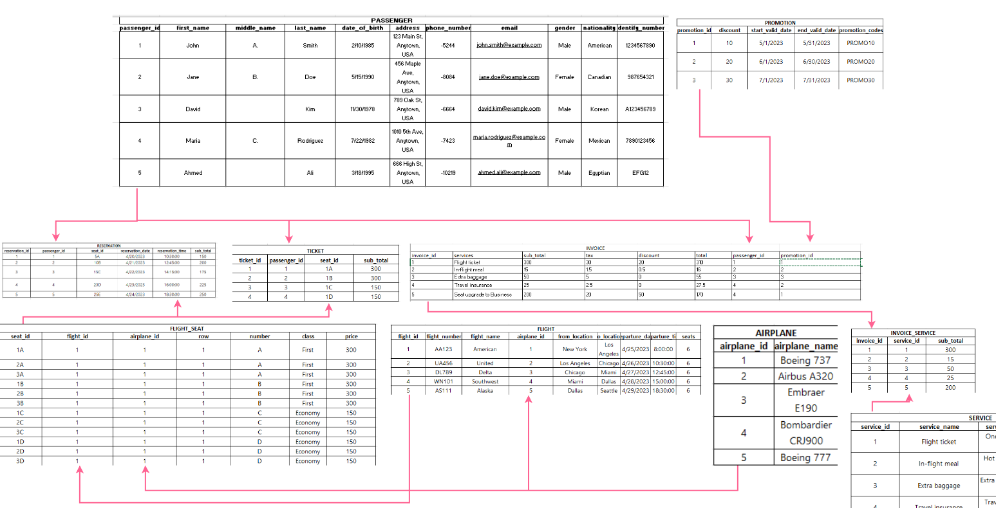

# **Task and member assignment table:**

|  |  |  |  |
| --- | --- | --- | --- |
| **Name** | **ID** | **Task** | **Status** |
| Nguyễn Minh Thành* | 20521920 | 1A-1C  2A-2C | Done |
| Nguyễn Văn Tân | 20521880 | 1B  2B | Done |
| Quách Vinh Quang | 20521811 | 1A  2A | Done |
| Tống Trường Thịn | 20521958 | 1A  2A | Done |

Note *: Leader